**Topic 5: Practical lesson. "Associativity". The concept of "association". Search for a connection between the form of an arbitrary closed line and a stylized image.**

1. **Association** is a psychological connection of ideas about various objects and phenomena, developed through life experience, with a real object. Abstract compositions are characterized by a refusal to depict real objects, extreme generalization or complete refusal of form, non-objective compositions (from lines, dots, spots, planes, etc.), experiments with color, this is a spontaneous expression of the artist's inner world [1].

- How can you convey the state of nature with paints?

Sounds of different strengths can be depicted with corresponding lines: loud ones - with a thick line, quiet ones - with a medium line, barely perceptible ones - with a thin line. The line captures the elusive in the movement of life. Intertwined in various forms, the line can be thin, exquisite and lacy, prickly and angry, gentle and velvety. The wealth of artistic materials helps the line to be extremely diverse.

- Is it possible to convey sound with a variety of lines (thin, thick, wavy, broken, exquisite, lacy, prickly, velvety, gentle, etc.) with a stroke, a spot? For example, the sound of a babbling brook, the roar of a waterfall, etc.

- What colors can be used to convey spring (bright and ringing, with the murmur of brooks and the singing of arriving birds, awakening nature)? Blooming gardens, warm showers and hot sun, so leisurely summer smells fragrant with scents in rich colors. Autumn waltzes in a round dance of leaves of various shades, driving with a cool wind with raindrops. Having shackled, having covered the tired earth with a blanket of snow, winter sings a lullaby like a blizzard, carefully guarding the sleep of nature.

The teacher demonstrates on the board with chalk the techniques of making various lines. He suggests that the students use lines to show the sound of a babbling brook, the roar of a waterfall, etc.

- Here, this is nothing other than abstraction. Abstraction is one of the main ways of our thinking. Its result is the formation of general concepts and judgments and is abstraction. Abstraction is constantly present in artistic activity. In decorative art, abstraction is the process of stylization of natural forms.

The perception of color is a complex process, conditioned not only by physical, physiological, but also psychological factors. Over the long path of development of human vision, the psychological impact of color has improved from elementary color perception to the highly developed sense of color of modern man.

In psychology, the sense of color, in contrast to a simple sensation, is understood as a complex, enriched perception of color, when certain images, memories associated with them, emotions, mental states arise. That is, associations associated with color appear [2].

Physiological effects of color on humans:

• red – stimulating, warming, active, energetic, penetrating. Activates all body functions, increases blood pressure, accelerates breathing;

• orange – tonic. Has the same effect as red, but weaker;

• yellow – physiologically optimal, least tiring.

• green – physiologically optimal, the most familiar to the organ of vision, calms;

• blue – calming;

• blue – the calming effect turns into a depressing one;

• violet – combines the effect of red and blue. Produces a depressing effect.

The activity of the visual organs can also excite other senses: touch, hearing, taste and smell. Color sensations can evoke memories and associated emotions, images, psychological states. All this is called color associations, which can be divided into physical and emotional (Fig. 3).

Physical associations:

weight (light, heavy, airy, oppressive);

temperature (warm, cold, hot, prickly, icy, burning);

textural (rough, soft, hard, smooth, slippery);

acoustic (quiet, loud, ringing, musical);

spatial (protruding, receding, deep, superficial).

Emotional associations:

positive (cheerful, pleasant, cheerful, lively, lyrical) (Fig. 2);

negative (sad, sluggish, boring, tragic, sentimental) (Fig. 1);

neutral (calm, balanced, indifferent).

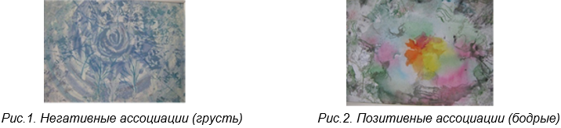

Figure 1. Negative associations (sadness) Figure 2. Positive associations (good)

2. Psychological relief block

1) Exercise "Collective landscape"

Purpose: relaxation, group cohesion, emotional balance.

Order of execution and instructions: music is playing. Participants close their eyes. The leader begins to describe the picture, and the participants are asked to continue "drawing" the picture after the leader, adding one or two elements to it (verbally).

**Associative compositions**

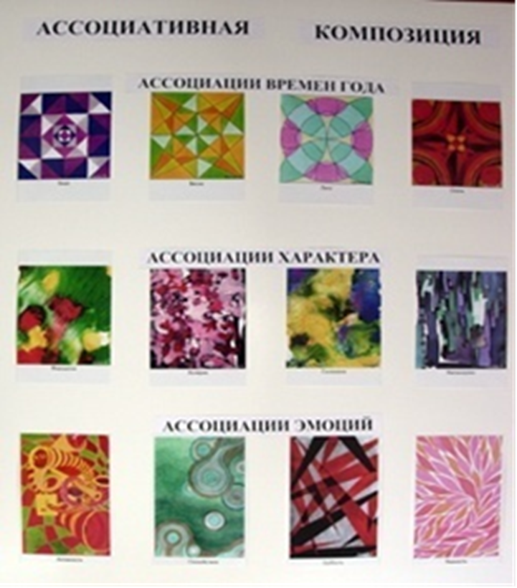

Seasons Associations

Character Associations

Emotions Associations

**What is an associative composition?**

Associative composition is, first of all, an abstract visual series that evokes a certain emotion, association. Similarity with a particular concept or phenomenon is achieved indirectly.

Associative composition is the basis of graphic design. It is built on the basis of a challenge.

The purpose of associative composition is to evoke certain emotions in a person through associations with the depicted images.

**Basic principles of associative composition.**

The first and most important rule is a ban on objects of the real world. They can be stylized, expressed through geometric shapes, lines and spots. Even in the most chaotic composition, a center is necessary. It is required so that the viewer's eye has something to "catch on to."

A good composition does not have many small details, for the same reasons as the previous rule. In a good composition, there is no desire to add or add anything.

And the last rule: "No rules!" In design, the rules take their origins from a specific task. This is especially clearly seen when performing a number of works with opposite themes, for example, sweet and sour, hot and cold, statics and dynamics.

**Where is associative composition used?**

Printing: in a poster.

Architecture: in the organization of space, in the development of a project idea.

Interior and exterior.

Decorative and applied art.

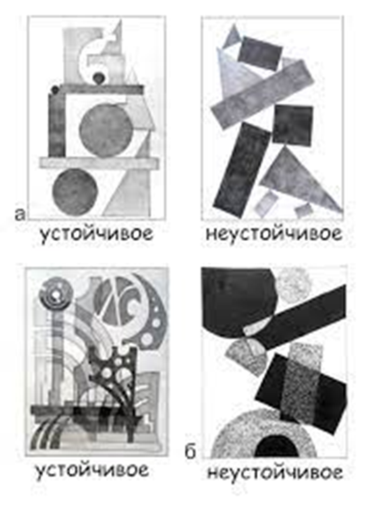

Stable unstable

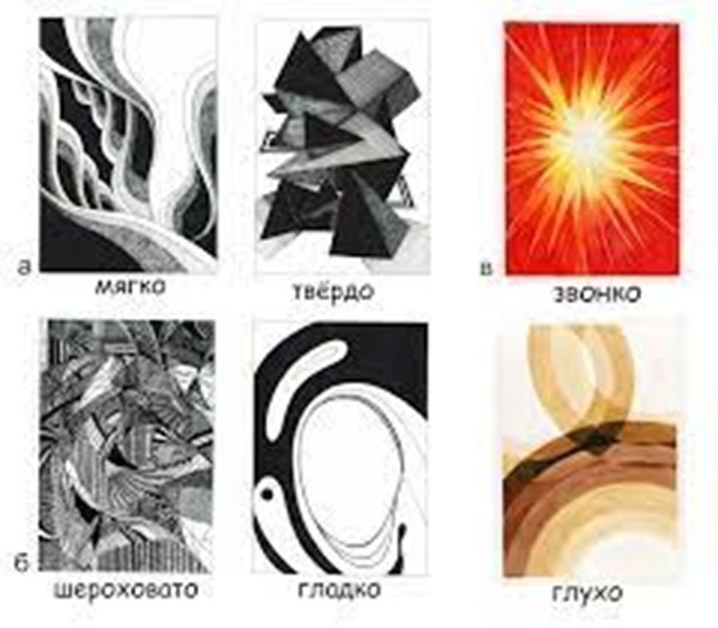

Soft hard ringing,

rough smooth muffled

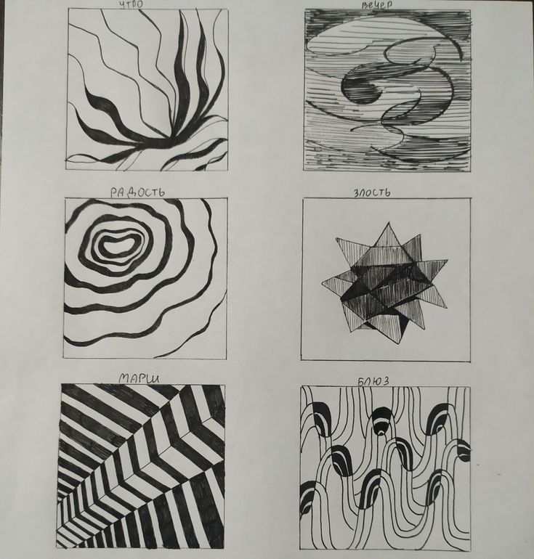

Morning Evening

Joy Anger

March Blues

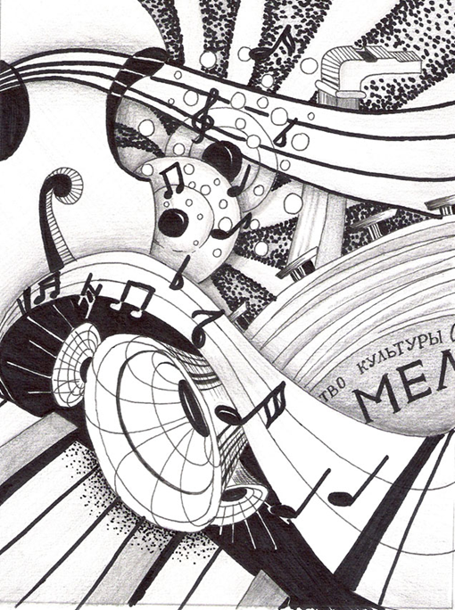

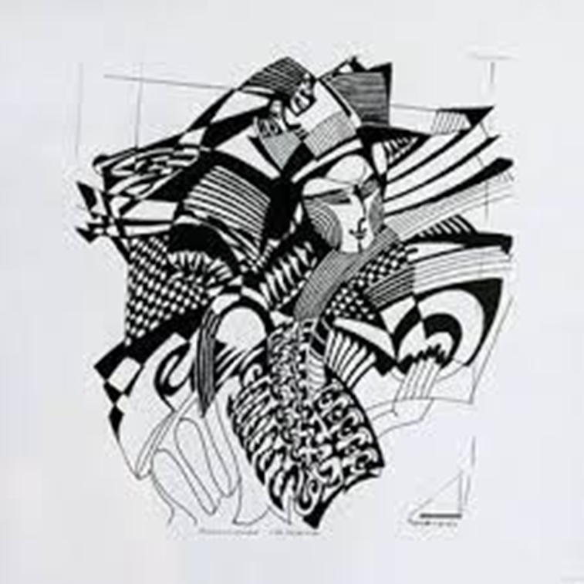

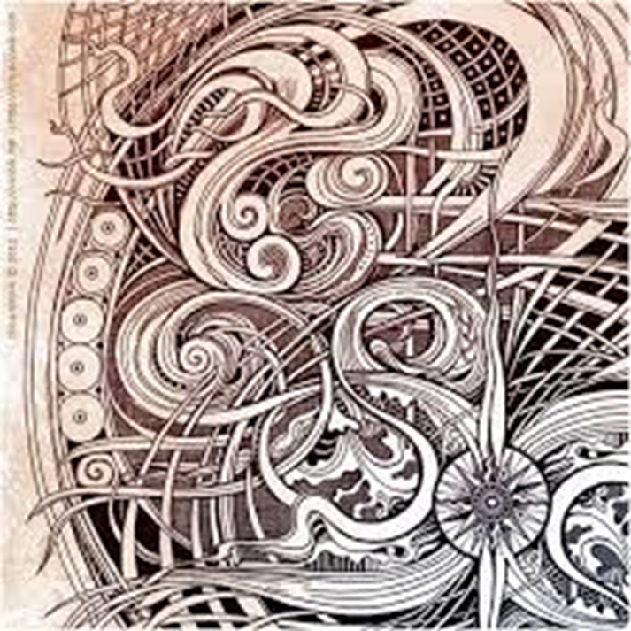

**It is suggested to complete the task on associative composition on any topic:**

1. Color portrait of the soul.

2. My character (choleric, melancholic, phlegmatic, sanguine).

3. Emotional associations (fear, sadness, joy, tenderness, rudeness, activity, calmness).

4. Taste associations (sour, sweet, spicy, salty, bitter).

5. Country associations (Egypt, Japan, Rus', India, America, Spain, Africa).

6. Musical associations (symphony, romance, piano concerto, march, rap, hip-hop, disco).

7. Aroma associations of smell (flowers, perfume, ammonia, bleach, greenery, all kinds of smells).

8. Association "Seasons" (spring, summer, autumn, winter).

9. Association of the elements (earth, water, fire, air).

**Choose 3 themes from 9 themes to choose from. 2 themes in graphic style, 1 theme in color paint.**

**Materials:** A4 format, pencils, black gel pens, gouache or watercolor paints, brushes.

**References and source links:**

1. Mironova L.N. Color in Fine Arts. A Manual for Teachers. – Minsk. Belarus Publishing House, 2003. – 151 p.

2. Paranyushkin R.V. Color Science for Artists: Coloristics / R.V. Paranyushkin, G.N. Handova. – Rostov n / D: Phoenix, 2007. – 96 p.

3. Vizer V. The Color System in Painting. A Tutorial. – St. Petersburg: Piter Publishing House, 2004. – 192 p.

4. Itten I.M. The Art of Color. / Translated from German; 2nd edition; Preface by L. Monakhova. – M., Publishing house D. Aronov, 2001. – 96 p.

5. https://www.youtube.com/watch?v=zAz-69snarE video